# Chapter 1

# 2.1 Analysis Specification

# introduction

Analysis is the most important factor in this project. In this phase we have analyze the existing system and investigated problem associated with it. We understand the limitation of existing system and got a clear requirement and we make new system. Bus ticket booking system is the desktop-based application. I have used C sharp programming language in this project. Ticketing is the most important module in this system. The user booking a ticket after the create account and if the user want ticket cancellation user can remove the ticket. User can create, update, delete the records and user can booking the ticket.

The activities that involve in the analysis are described below:

* Identifying the stockholders:

In this scenario the main identification is to identify the stockholders. It makes the user or product developer to develop the resendable product to develop. Manages of product is far better than when there is identification of stockholders.

* identify the main objectives:

To identify the major requirements from the stockholders. If they identify the main things in the character, they will be easier to identify the risk before. Identifying the main objective helps to prevent the process more combustion.

* Definition of scopes:

To helps to manages the scopes the before the project begin. It makes the stockholders and the developer how to identify the scopes before the project begins.

* Evaluate the project:

In this step there is the identification of options, customization, integrate of the system that is going to be implement in the future. Thus, this helps to manages the productivity more accuracy, reliable, maintainability.

There are the vast reasons for the analysis process. The main reasons for the analysis process are:

* To identify the problems
* To manages the resources
* To analysis the requirement before the project
* To maintain the risk
* To success the product
* To collect the requirement from stockholders
* To satisfy the customer
* To meet the requirement with high acceptance

In this project I used CATWOE analysis

CATWOE analysis is an analytical method for determining the problem and process during soft system analysis.

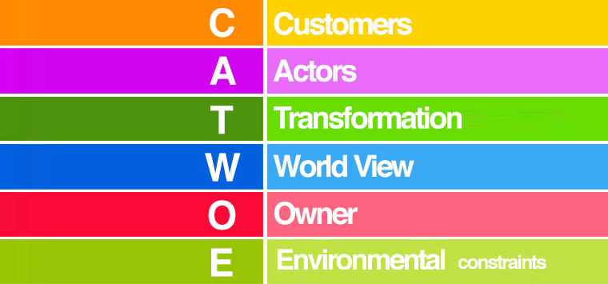

Customer: For this project customer were asked following questions like who are they, and how does the issues affect them.

Actor: who is involved in the system

Transformation: what process or system affect by the issues

World view: to identify the major views from the others against the product.

Owners: who are the owners of impacted system and how are they related.

Environment: what are the environmental constraints and how will it impact the solution?

# Feasibility Study

Feasibility study play a major role in the analysis of the system. The study shows the requirement that wishes from the stockholders. This makes the feasibility to identify the major requirement and items that under it. Identify that the requirement of the feasibility is possible or not. The very decision of the system analysis is given below

# Types of feasibility study

1. Economic Feasibility:

Economic feasibility is the most important Role in project that determine the cost and benefits of the system. And compare with budget. If benefits are more than cost the project is economically successful. In this assessment the economic conditions for the project can be approved.

1. Technical Feasibility:

In this study identifies the computer (hardware and software) to determine the enough technical resources purposed of the system. The main goal is the system is technically feasible. For the ticket booking system the term technical feasibility can be done to upgrade to next one.

1. Schedule Feasibility:

Scheduling is the most important factor in the system and measure the how reasonable the project timetable. The term scheduling is done all over the project into the different task divided into the sub function or task in order to meet the full a final project.

1. Operational Feasibility:

In this study measure the how well a solution will work or accepted in the system. It identifies that the company have technical expertise or not. In this project the technical feasibility is possible.

1. Legal Feasibility:

My project is legally feasible with government rule, regulation and laws. In this ticket booking system the legal side of the government is watch over to identify the whether the term and condition is violated. In this system the legal feasibility is more watched to not touch the legal terms of the government. The legal approve for this project is completely legal to do.

# Requirement Analysis

# Functional Requirement

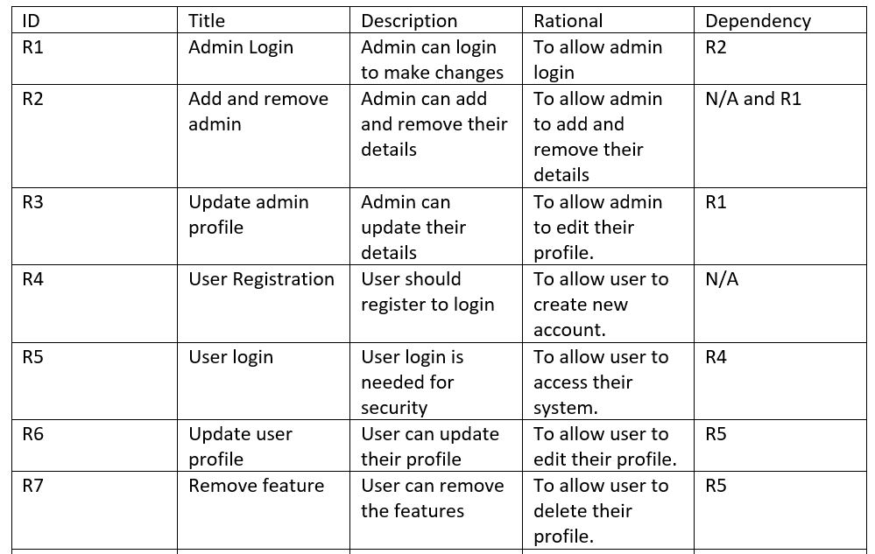

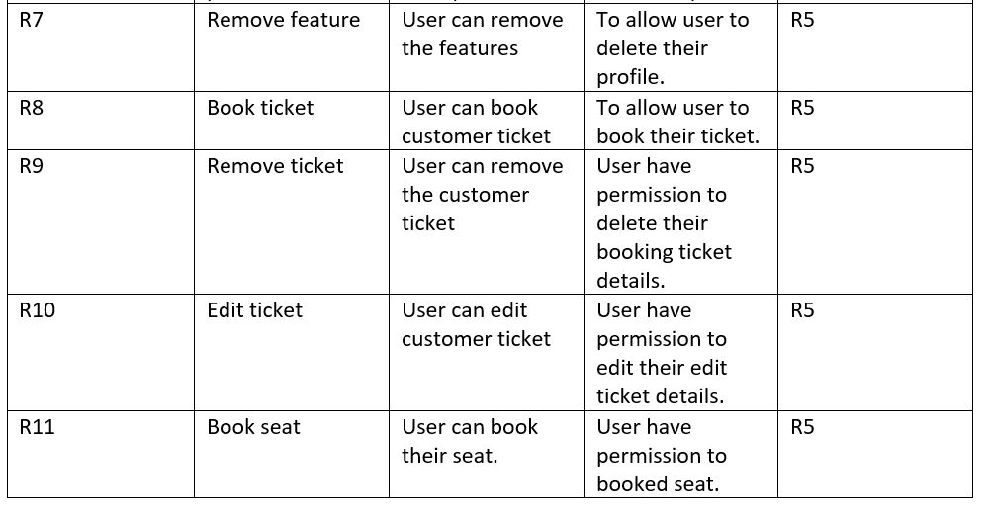

# Nonfunctional Requirement

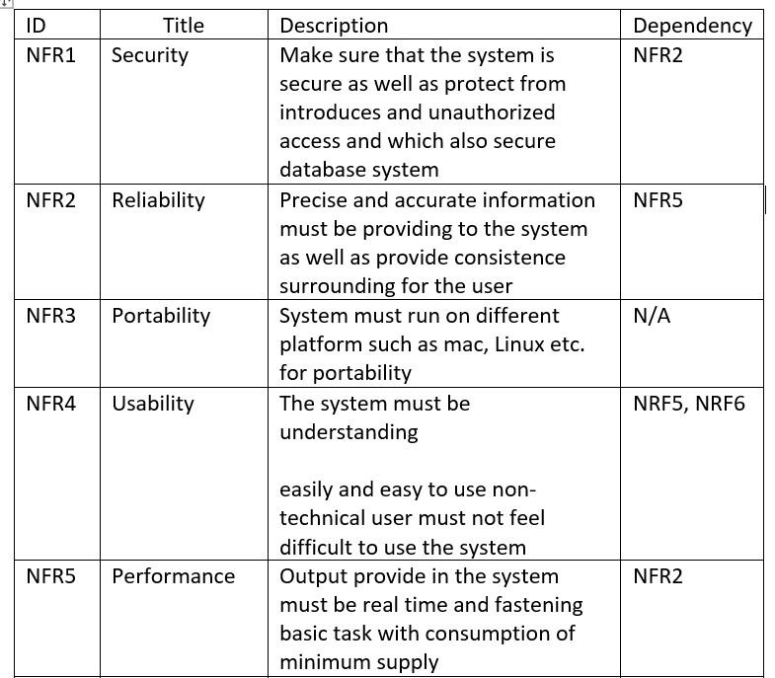

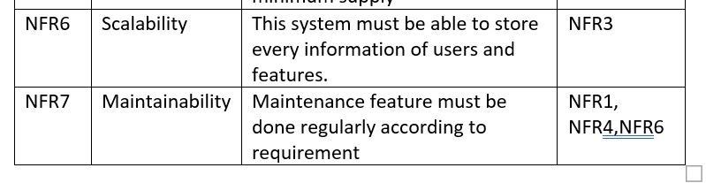

# Moscow Prioritization

* Must have:

must haves be the requirement which must be included in the final solut*ion. These are the priority list.*

* Should have:

should have is the important in the project but not necessarily. These are the second position of priority list.

* Could have:

the solution is aspect these requirements are not included.

* Won’t have:

won’t have do not affect the success of project.

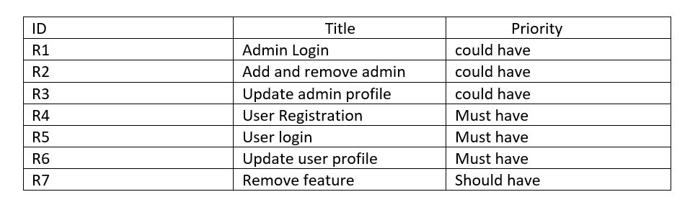

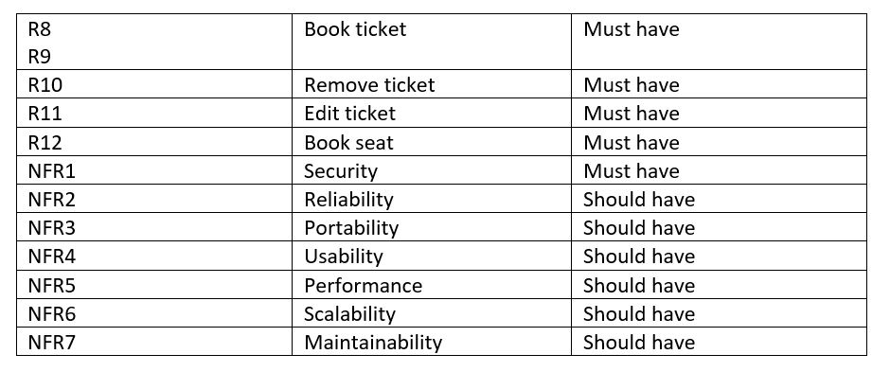

# System requirement specification

Hardware requirement

|  |  |
| --- | --- |
| RAM | 2GB or higher |
| Operating system | Windows 7/8/8.1/10 |
| Processor | Intel core 2 duo or higher |
| System type | 32 bit / 64 bit |

Software Requirement

|  |  |
| --- | --- |
| Programming Language | C-sharp and database |

# Use case Diagram

Use case diagram can be used to describe the functionality of system in a horizontal way.

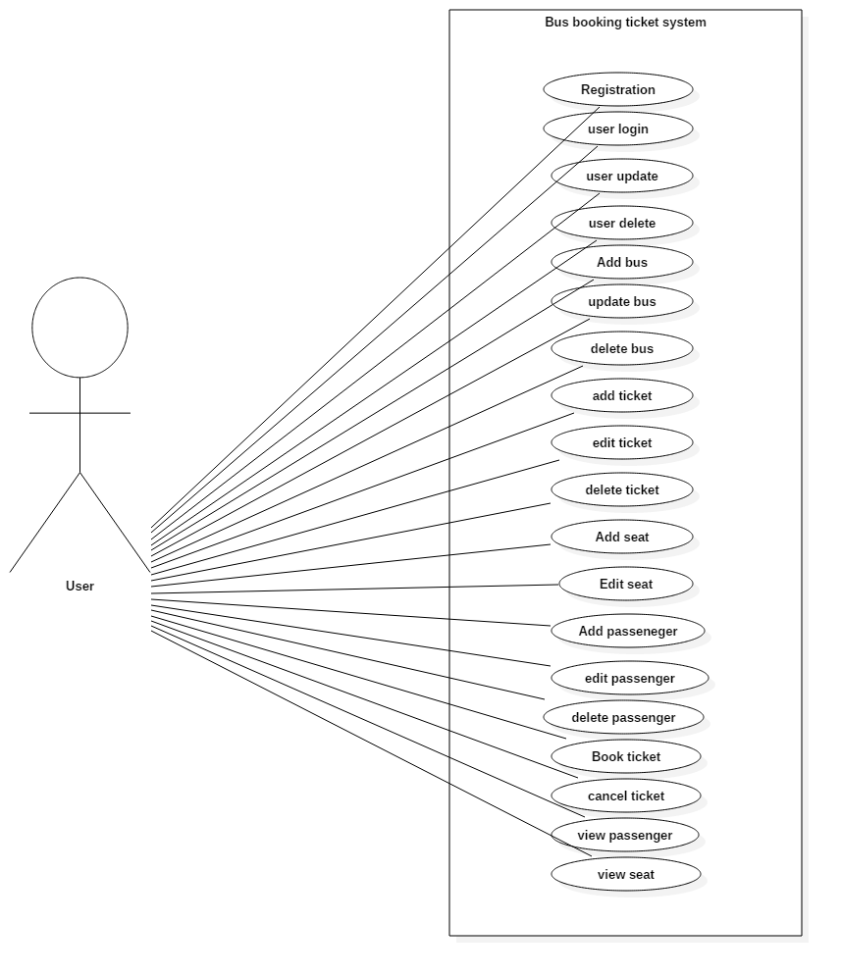

User story:

In this small application is compatible of storing the data for those who enroll in the booking system. The system is capable for recording the details of customers. the main user admin can do all the things like delete, update and view as well changes. The customers can book for the buses. They can book as their choices of seats. The price for booking can be recorded. the customers can cancel the booking. the price for the each can also be recorded in the system. The details of customers are recorded as their destination also be included while recording it. They can get the ticket but not included into system due to choose of management searching of customer data can be also included.

|  |  |  |
| --- | --- | --- |
| List of possible class(noun) | List of possible attributes (Adjectives) | List of possible operations(verb) |
| User | Booked | Edit |
| Customer | Bus | Update |
| Booking | Record | Delete |
| Bus |  | Add |
| Seat |  | Search |
|  |  | Booked |

# Class Diagram

